# Design alternatives

## Project description

Our project is a game designed for kindergarten children. It follows the storyline of a Romanian fairytale, “La grădina zoologică”, written by Marin Sorescu. Besides learning the story, the game has as scope developing children’s vocabulary and their counting skills in range from 1 to 9. All these are made in an interactive way, creating and maintaining children’s interest. Therefore, it will have an educational role and in the same time, the kids will enjoy playing the game; they will learn literature and mathematics while having fun. Because is designed for kindergarten children, they will be able to use the application by themselves, without needing the help of an adult. Although the kids can play by themselves, the application can be useful to teachers in classes. As teaching material, it can be used for making lessons more interesting and interactive for kids.

## Requirements summary

The system must be designed in a way that can be used in kindergarten, by children, at a computer. Connection to the internet is not required. The application must be an illustrate story, having an educational scope. It must follow the storyline of “La grădina zoologică”, written by Marin Sorescu. The system is needed to be used as a teaching material at lessons from literature and mathematics domains. In addition to understanding the story, the application aims to develop children's vocabulary; therefore, the new words from the story will be explained in context. The names of the animals and their attributes will also be extracted. In this way, an introduction to the parts of speech will be made, more precisely to the nouns and adjectives. The math part will consist of exercises related to counting, the numbers ranging from 1 to 9. The application should be adapted to the age of the children (5-6 years old). Considering the fact that, at this age, they do not how to read or write, all the information must be presented intuitively. They should be able to use the application individually, not depending on the help from an adult.

## Design space

#### Difficult Requirements

Most of the afore mentioned requirements are fairly easy to implement, due to the fact that they should be kept simple, such that kindergarten children will be able to understand, remember and complete them successfully. One of the most difficult requirements would, hence be keeping the application simple enough so that the children will be able to finish all the tasks.

#### Tradeoffs

#### Task support

Most of the tasks are easily supported regardless of the application’s environment or implementation due to their native simplicity given the user’s age range. However, if the application will be implemented for web, there should be a JavaScript library for graphics that supports game-like implementation for web applications.

## Design summary

## Design alternatives

### Proposal 1

This design alternative aims to fit children needs. From research, we know that kids need feedback on everything and they love a good challenge. As a result, this proposal is a game, having three levels. In each level the children will be taught something different: zoology, environment, mathematics.

Since users except consistency, the proposal uses the same cartoon style for images and the same background through the entire game. The application is entirely built for children, so bright colors and cartoons are the most appropriate idea.

The game will have audio instructions. Also, feedback will be given audio, through sounds.

During the entire game, the animals shall look the same, not to be confusing for the child.

**Homepage**:

When starting the application, children will not be required to click any button for starting the game. They will be shown a progress bar to inform how much time is left until the game starts.

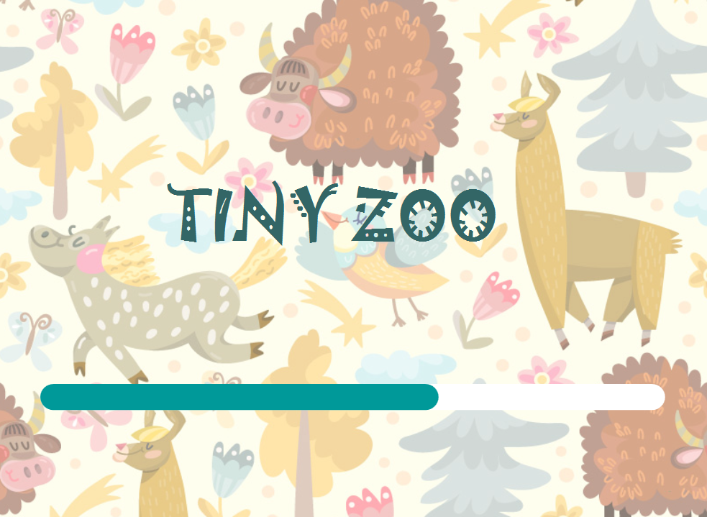

**Level 1 – Riddles**

First part of the game will follow the story “In gradina zoologica”. Children will hear parts of the story and they will have to guess the animal, seeing only its contour. When he clicks on the contour, the colored animal will appear on the screen. After each animal, a voice will ask in Romanian “Cine sunt eu?”. The voice will try to imitate the voice of the animal.

Scenarios:

Wolf – “Il rogi sa te ia putin in circa sic and colo te mananca. Hei, ca pe Scufita Rosie te-ar manca, cusca daca l-ar lasa”.

Tiger – “Iata-l adus din Bengal cu cheltuiala. Toata blana de pe el e naturala”.

Ostrich – “Mirela, acela nu se striga cutu cutu, ca el e..”.

Crocodile – “Balaurul care se prajeste pe nisip, bazinul de langa el e Nilul”

Elephant – “El va priveste ursuz, e intrebuintat in loc de troleibuz. Incaleci pe el dimineata si pleci la scoala, mergand o mie de statii prin padurea ecuatoriala.”

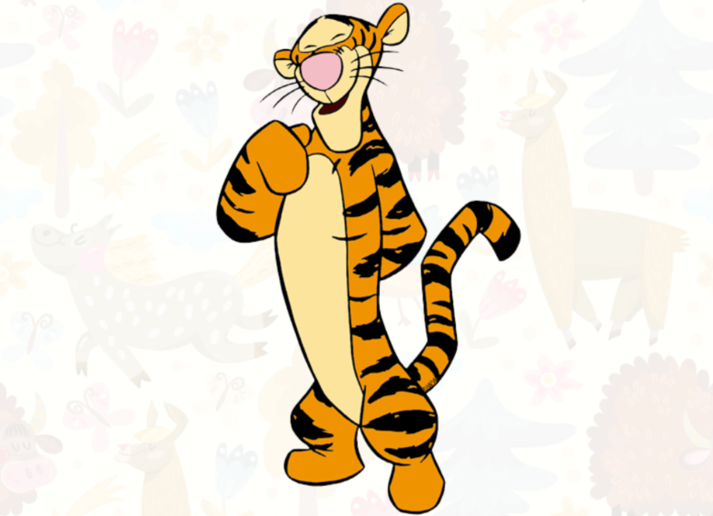

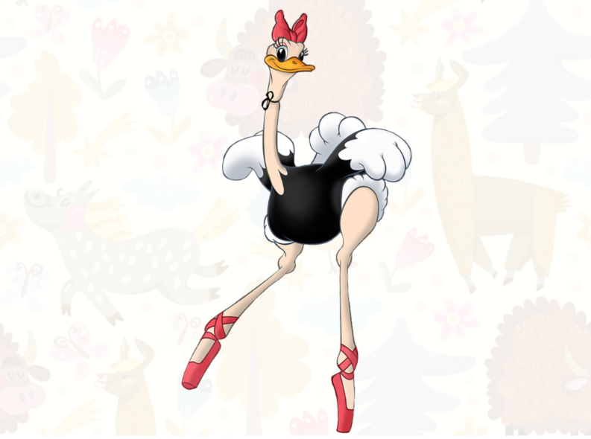

**Level 2 – Environment**

For each animal, the child will have to draw the correspondence between the animal and its natural habitat. Drawing the correspondence means clicking on the animal and then clicking on its habitat.

The child will receive feedback both if he is correct or not. If he chose the correct correspondence, another animal and another habitat will appear on the screen.

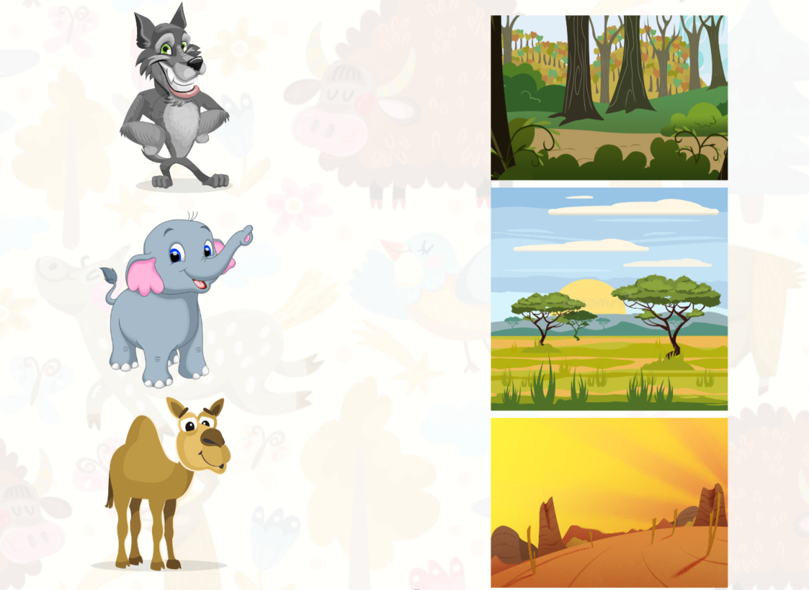

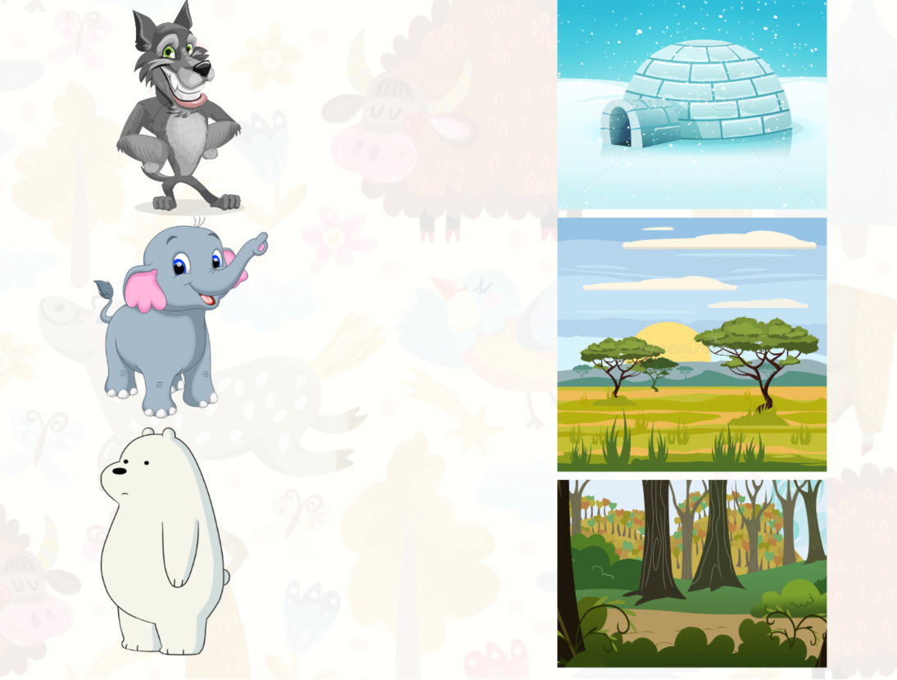

**Level 3 – Feed the animals**

The child will be asked to feed the animal choosing items on the screen. For example, the story says that the wolf eats sheep. The child will be asked to feed the wolf two sheep.

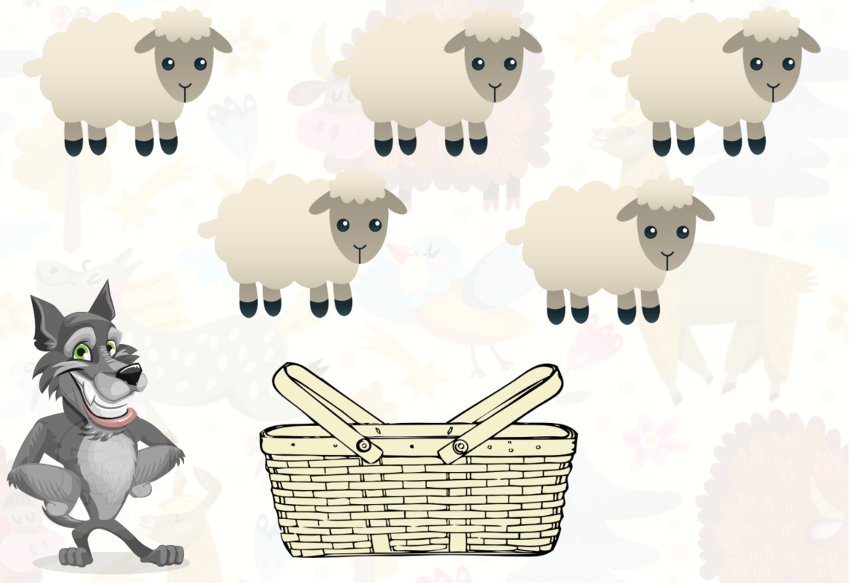

### Proposal 2

The application is a game for kindergarten children. Because the users should use the game by themselves, they will be guided by audio instruction and by suggestive images and icons. Therefore, there will be no displayed text or complicated menus. During interaction with the application, children will receive feedback constantly. The backgrounds and characters will be animated and colorful, in order to be attractive to the kids.

The game will follow the storyline of “La gradina zoologica”, by Marin Sorescu. During the game, the story will be narrated in audio format, because the kids do not know how to read. The story will be divided into several parts and after each part a question will be addressed. The question will be related with language or mathematics domains, which will have as scope understanding the story, developing vocabulary and practicing counting in the range from 1 to 9. The story will continue only after the kids give the correct answers.

After the user opens the application, the following window will appear on screen:

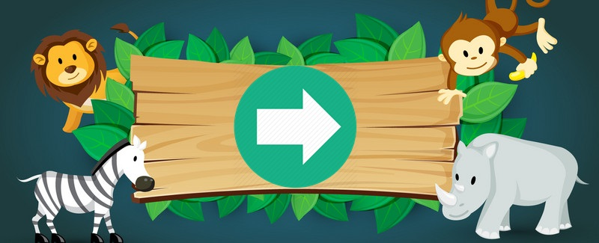

To start the game, the user must click on the green icon from the center of the window. When the cursor is hovering over the icon, the cursor will change from a pointer to a small hand.

When the game starts, the story begins too. At each part of the story, a different image will be displayed. After the part of the story ends, a question will be addressed. The user has to find the answer in the image displayed and to click on it.

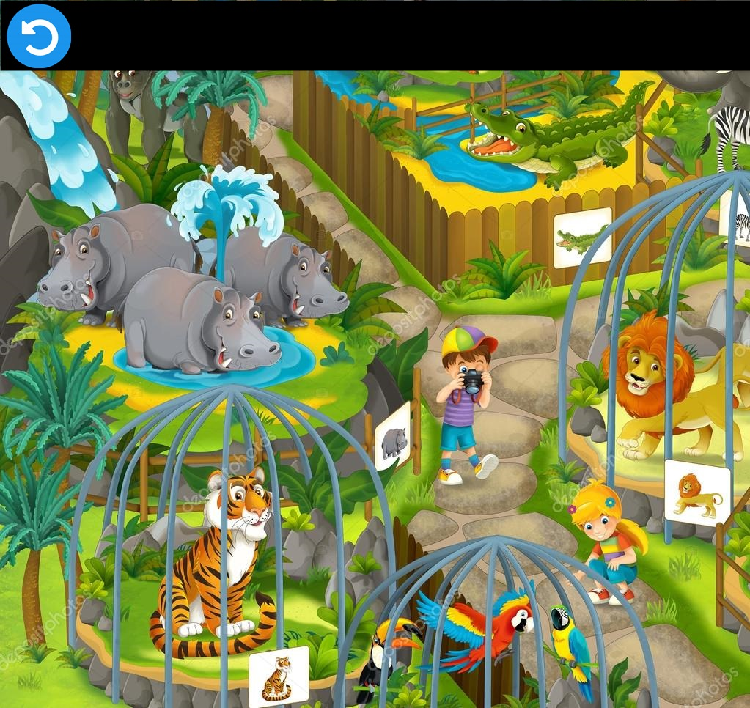

For example, if the image from above will appear on the following part of the story:

* *Grădina zoologică e un fel de magazin de jucării, unde tigrii, girafele şi leoparzii sînt vii. Rogi lupul să te ia puţin în cîrcă şi cînd colo te mănîncă. Hei, ca pe Scufiţa Roşie te-ar mjnca, cuşca dacă l-ar lăsa. Dar, vedeţi, aceste cuşti de fier, sau colivii, sînt ca nişte bunicuţe ale lor : au grijă să nu facă prostii.*

one possible question can be *Care animale se află in cuşcă?,* and to answer to this, the user must click on the tiger, lion and parrots.

If this image will appear after the following part:

* *E tîrziu: a sunat şarpele cu clopoţei de ora trei. Şi animalelor nu le place să mai întîrziem pe-aici după orele lor de servici.*

a question can be *Care animale apar in grupuri de trei?,* and the user must click on the parrots and on the hippos.

Every part of the story will have a different image, to maintain user interest. In this way, each proposed learning domain can be covered by questions.

After each answer, the user will receive a feedback. If the answer is correct, on the screen will appear a happy animal, otherwise, will appear a sad one.



The feedback image will be displayed a few seconds and will disappear automatically after that. The story will continue only after the user gives the correct answer.

The user has the possibility to redo the story and the question. This can be made by clicking on the icon from the top of the window.

### Proposal 3

This design describes a game for kinder garden children that helps them learn different concepts from diverse fields such as mathematics, zoology, grammar and even literature.

The homepage will be just a simple loading screen, that disappears by on it’s own and then character choosing page appears. The user will choose a character (boy or girl) and then the screen changes automatically to the game.

When the game begins, the audio starts playing a recording of the tale “La gradina zoologica“ by Marin Sorescu. The user will move the character forward and while the story unfolds, the “obstacles” that the user comes accros are strongly related to the story. For example:

*“Rogi lupul să te ia puţin în cîrcă şi cînd colo te mănîncă. Hei, ca pe Scufiţa Roşie te-ar mjnca, cuşca dacă l-ar lăsa. Dar, vedeţi, aceste cuşti de fier, sau colivii, sînt ca nişte bunicuţe ale lor : au grijă să nu facă prostii.”*

This paraghraph will create the following scenario:

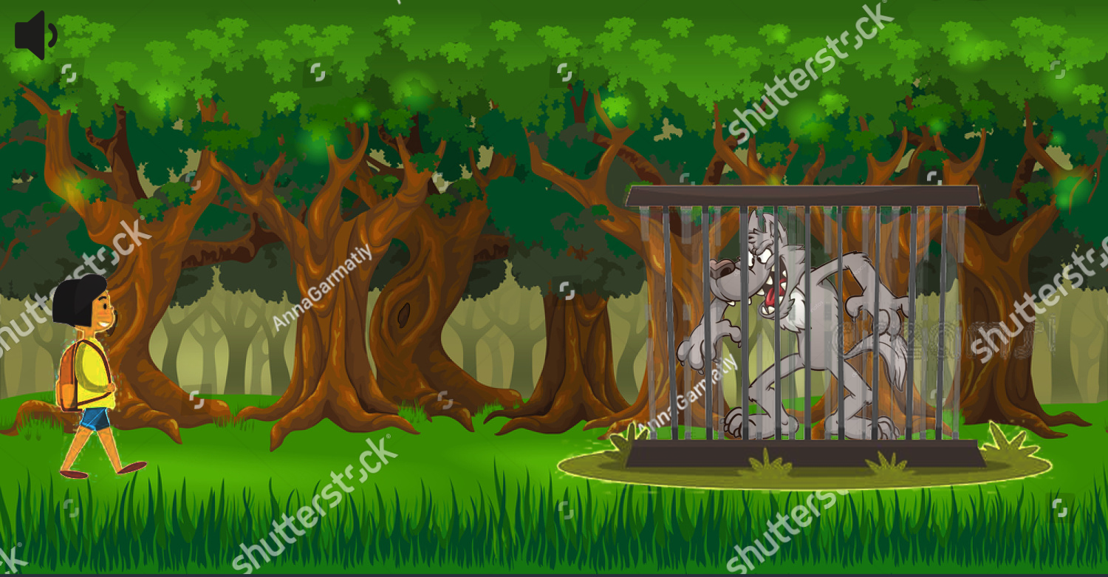

And upon clicking on the obstacle (or maybe when getting closer to it, say 20pixels), the story will be even better represented.

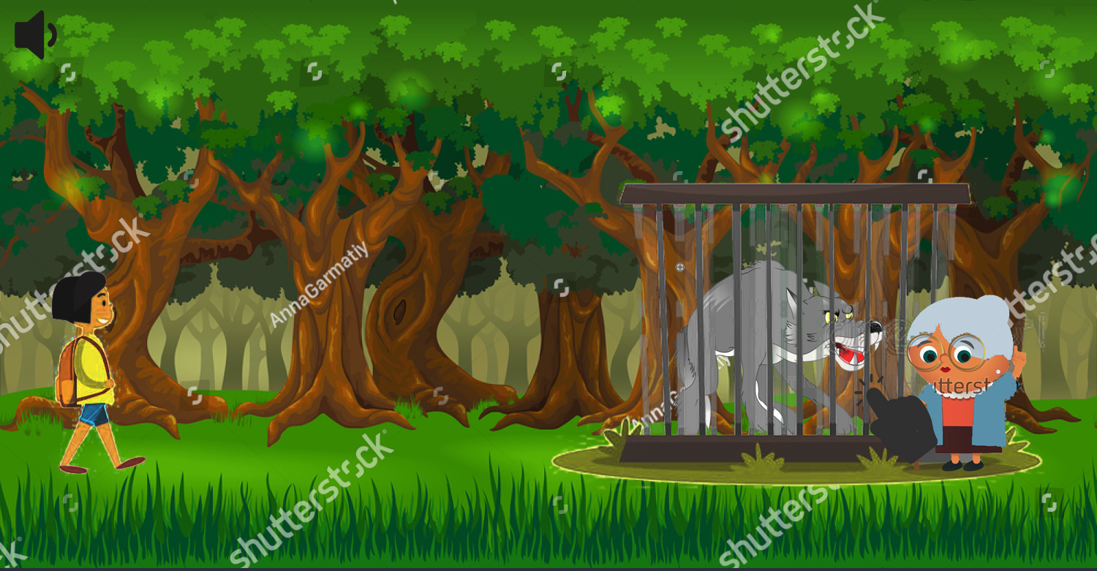

These obstacles can be created such that the user has to answer a question that is asked upon click, such that the game can progress only on correct answer.

### Proposal 4

This proposal is designed so that the story that is the baseline for the system is presented first and then games that will help children develop on areas like mathematics and grammar and also quiz them about items learned in the presented story.

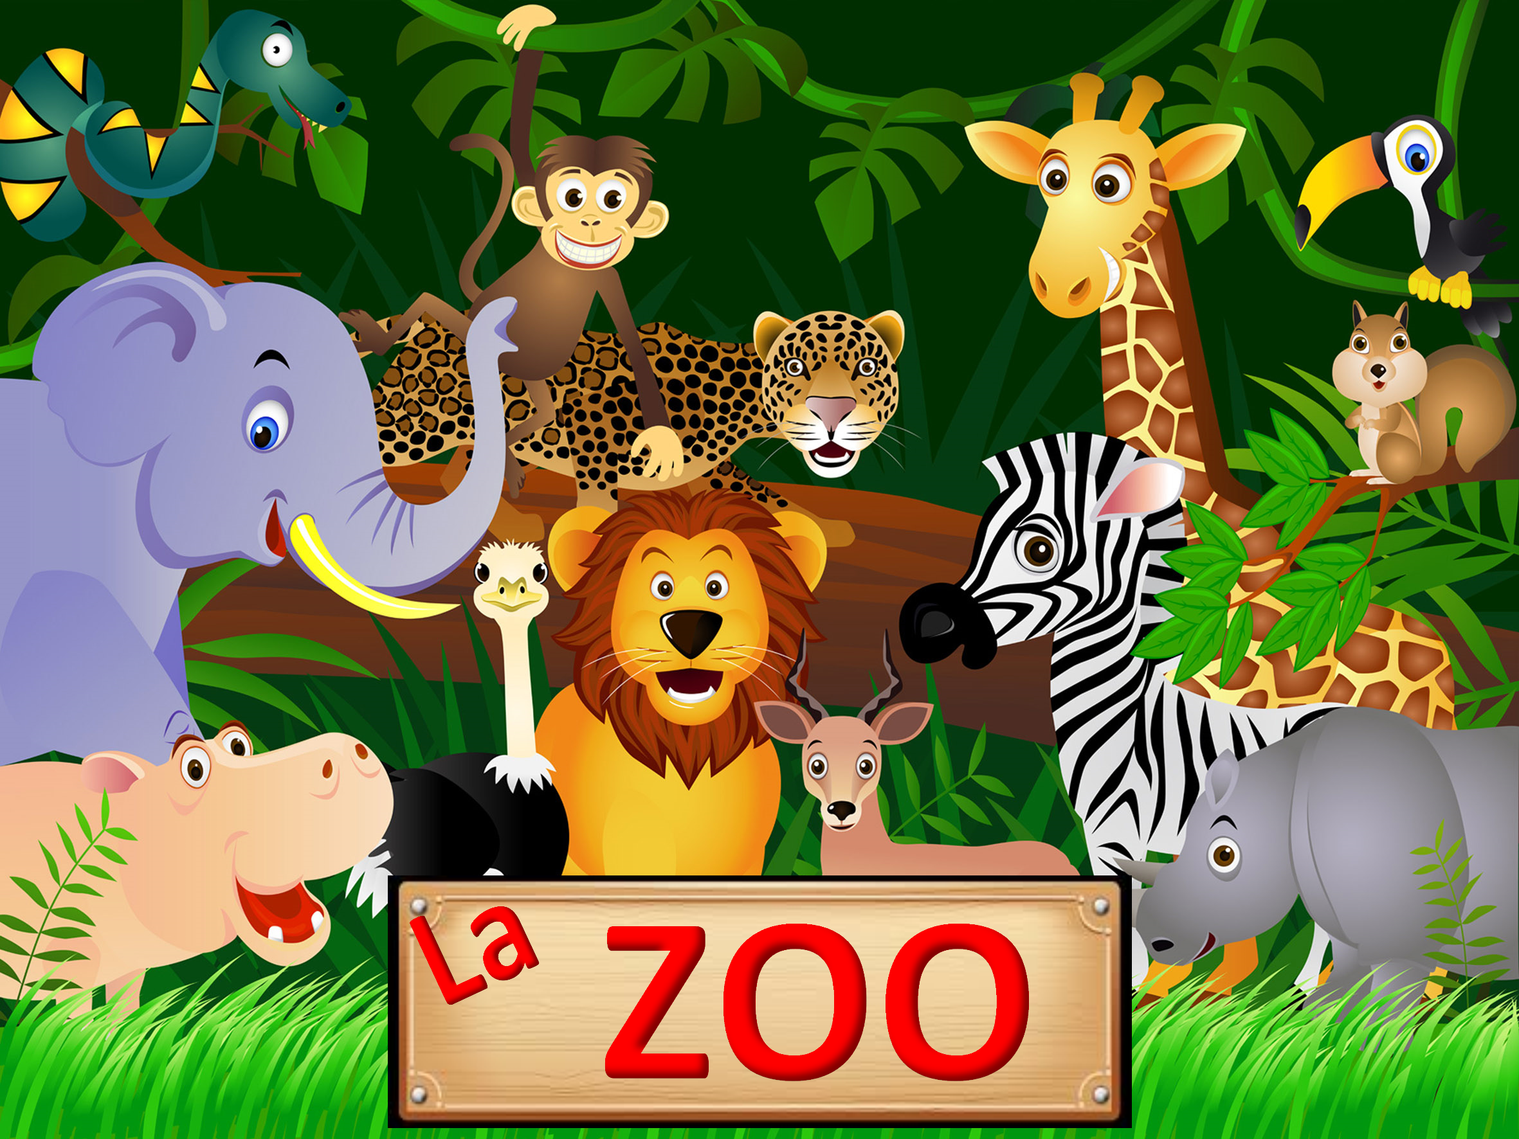

The home page will present the animal at the zoo that also appear in the story. There will be a vocal presentation of the system, an introduction from the story and what the children should do next. They are able to press on every animal to find out their story. A counter will be present to let the user know how many animals has he or she clicked on and how many remained. After finding the story of an animal the color of the animal will change in order to show to the children that the animal has been clicked. When presenting animal stories, some unknown words will also be explained to the children like ‘fauna’, ‘jivine’, ‘zoologia’.

After all the stories have been discovered, the user will be presented with an arrow to proceed to the games. All games will be explained to the children using sound. Examples of games are the following:

* Adjective or newly learned words will be given and the users need to make correct associations to animals or to what exactly describes the new word. (e.g. “Cu studiul cui se ocupa biologia?”)

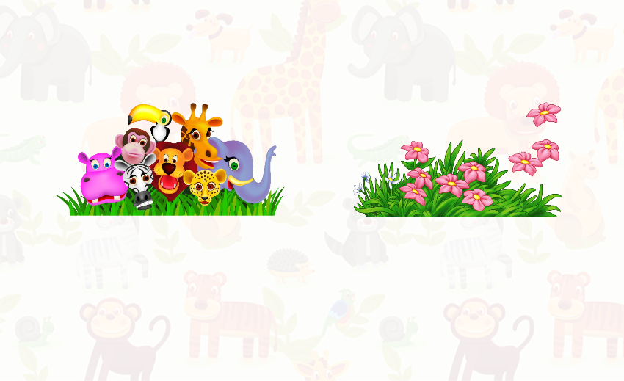

* Associate animals with their natural habitat (e.g. “Care din cele doua animale traieste in desertul Sahara?”)

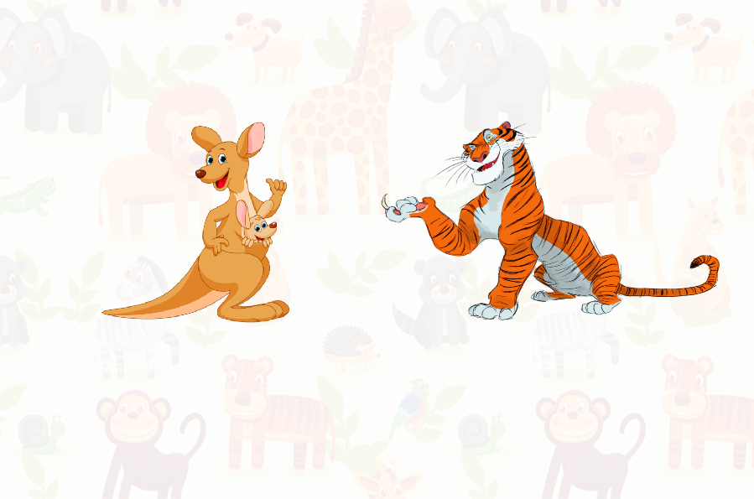

* Choose between two choices given some criteria; e.g. the user is requested to click on the bigger elephant

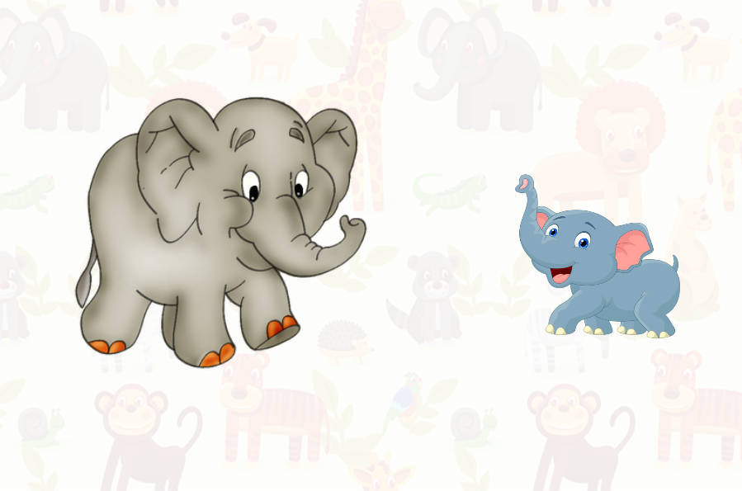

* Choose the correct number given a math problem: first the problem will be presenting using , for example, animals and then the numbers to press on will appear; when hovering on a number, a sound will play with the numbers name. (e.g. ask the children if there are two ostriches at the zoo and another one is brought by the zoo keepers, how many ostriches are now at the zoo for children to see?)

